**Authors:-**

15 March 2020

1

**John Halstead and Mary Widger**



**BrueCrew 2018/19 Report**

**Riverfly Monitoring**



year on year comparison and the results are dependent on volunteers’ increasing ability to sample. The data we

Cole Manor

•

In August 2019, 2 sites fell below the trigger level set by The Environment Agency:

prior knowledge of the sites and experience of similar sites in the West Country.

The trigger levels for the Upper Brue Catchment are set/adjusted by The Environment Agency based on their

score (**A**ngler’s **R**iverfly **M**onitoring **I**nitiative) at any site is below a predetermined value called the Trigger level.

frequently and that any action required is taken at the earliest opportunity. Action is initiated if the total **ARMI**

monitoring scheme enables the Environment Agency to ensure that biological water quality is checked

collect is entered into the national riverfly database and, once verified, are freely and publicly available. This

•

On the Brook and Pitcombe sites started data collection in April 2019. This report therefore will contain little

discontinued and the site at Cole Manor was appropriate. This site started data collection in November 2018.

surveys The Environment Agency advised that the site sampled at the old dam upstream of Batt's Hole should be

The surveys on 5 sites began in summer 2018 following initial one day training in the spring of that year. After 4

**Summary**

**2.**

This network is part of the BrueCrew and is coordinated by Mary Widger.

too high to safely survey.

always possible. Another reason for incomplete surveys was the wet autumn/winter when water levels were

•

15 March 2020

2

oil discharge from car driving through the ford above Mill Dam

We try to arrange for someone else to cover, if regular volunteers advise that they cannot survey, but this is not

floor cleaning discharge into the river at Church Bridge

•

a concrete mixer was washed out at the stepping stones in Bruton

•

Observation/Reports were noted on the occasions of the following:

to take a further sample within the week. Following this re sampling no further action was required.

Due to administrative issues only the Pitcombe breach was reported to The Environment Agency who advised us

Pitcombe

3 Ton Bridge

Cook's Farm

River Brue

•

Results from 80 surveys were received from the 7 sites across the Upper Brue catchments. These sites are:

September 2019 we have experienced rain almost every day, with consequent impact on our river levels.

significantly drier than in recent years and were followed by wetter and milder winters. Anecdotally since

We have no detailed information on the weather over reporting period: both summer 2018 and 2019 were

conditions and personal circumstances.

River Brue. The suggested survey times were monthly. In practice, these dates were flexible due to river

This is the first report of the riverfly monitoring undertaken by the BrueCrew in the upper catchment area of the

**Introduction**

**1.**

River Pitt

Combe Brook (Mill Dam)

On the Brook

Combe Brook

•

Pitcombe Bridge

**Riverfly Monitoring BrueCrew 2018/19 Report**

•

Cole Manor

Church Bridge

**On the Brook**

**Cole Manor**

**Church Bridge**

15 March 2020

3

**Pitcombe Bridge**

**Combe Brook Mill Dam**

The map is downloaded from OpenstreetMap

“© OpenStreetMap contributors”. The cartography in the map tiles, ,

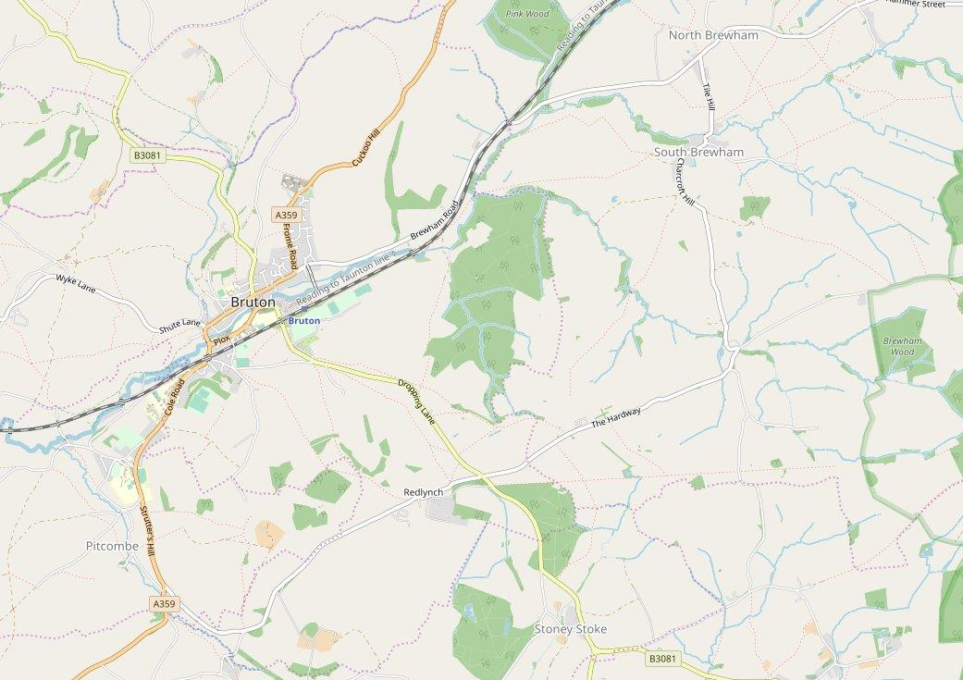

are licensed under the Creative Commons Attribution-ShareAlike 2.0 licence (CC BY-SA).

**Map of Upper Brue catchment showing location of measurement sites**

**2.1.**

included in the 2020 report.

Science Initiative) survey, recording turbidity, dissolved solids and phosphates This extra information will be

**Three ton Bridge**

In addition to the Riverfly survey most volunteers have now begun to take part in the Westcountry CSI (Citizen

**Cook’s Farm**

**Key**

**3.2.2.**

**Cased Caddis**

**Flat-Bodied Heptageniidae**

**3.2.4.**

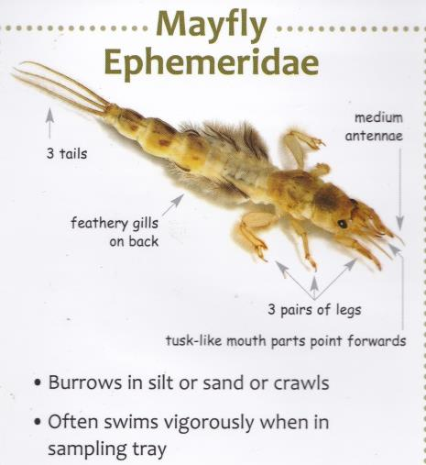

15 March 2020

4

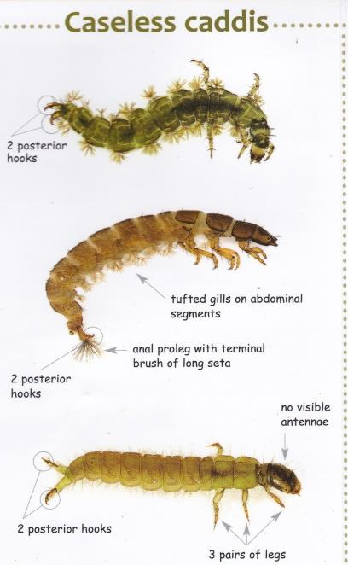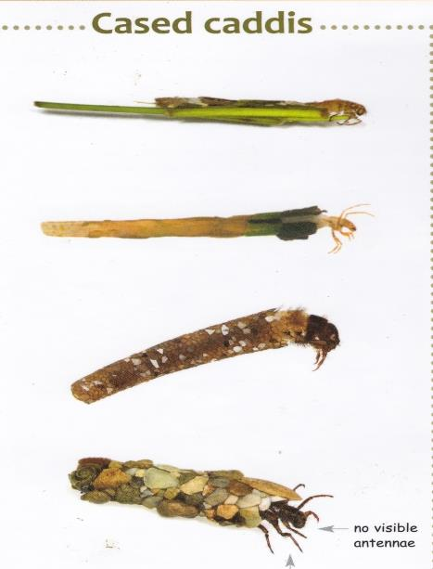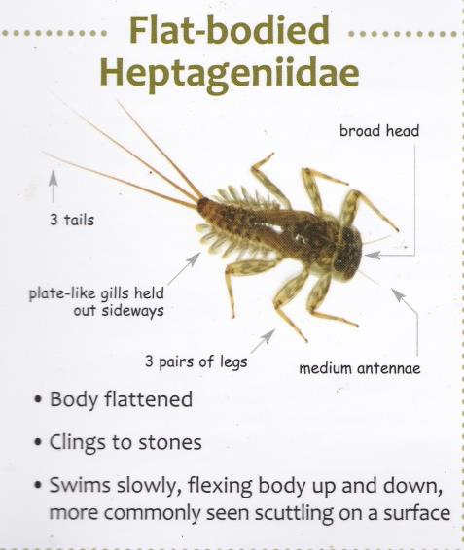

Eight species of invertebrates have been designated as indicators of the health of the river. These are

**Pictures of each Invertebrate Species**

**3.2.**

the Riverfly partnership.

of each species are estimated, recorded and given an ARMI score according to the procedure laid down by

separated from the sample, which usually contains several more species and sometimes small fish; numbers

**sampled (reproduced from the Riverfly**

time.

minute manual search of the underside of large stones. This allows comparable samples to be taken over

The sampling method is a 3 minute kick/sweep sample using a standard kick sample net followed by a one

**Kick Sampling**

**3.1.**

**Description of measurement procedures**

**3.**

**Mayfly Ephemeridae**

**3.2.3.**

**Caseless Caddis**

**3.2.1.**

**Dr Cyril Bennet)**

**Riverfly Partnership 2020, image copyright**

**Brochure** **with kind permission from the**

**Olives Baetidae**

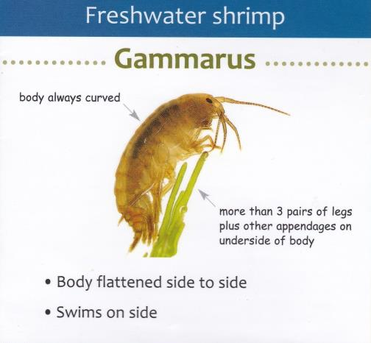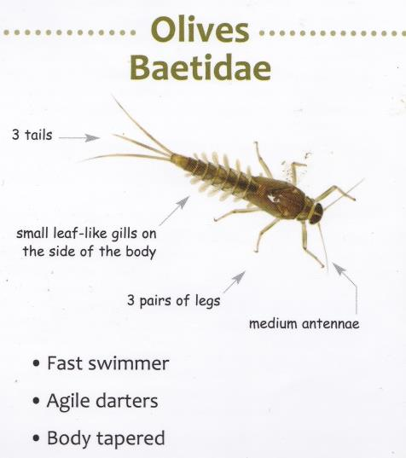

**3.2.6.**

**Freshwater shrimp Gammarus**

**3.2.8.**

5

15 March 2020

**3.2.5.**

**Blue-winged Olive Ephemerellidae**

**3.2.7.**

**Stoneflies**

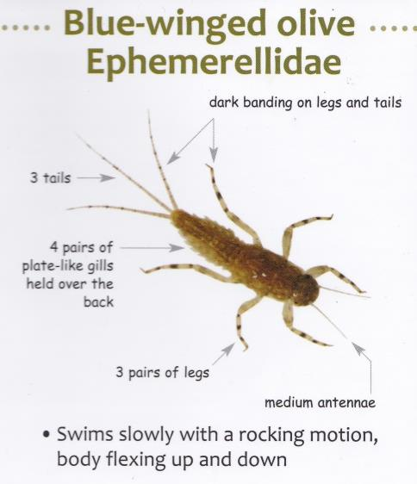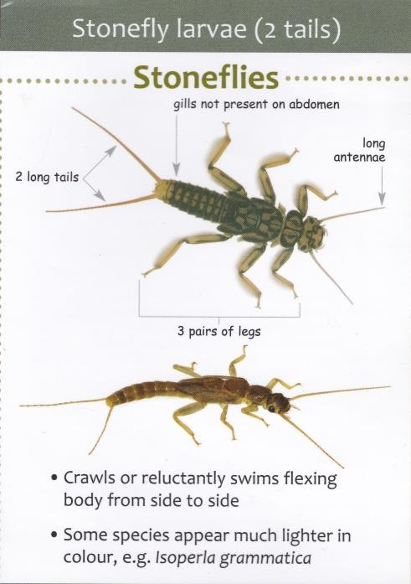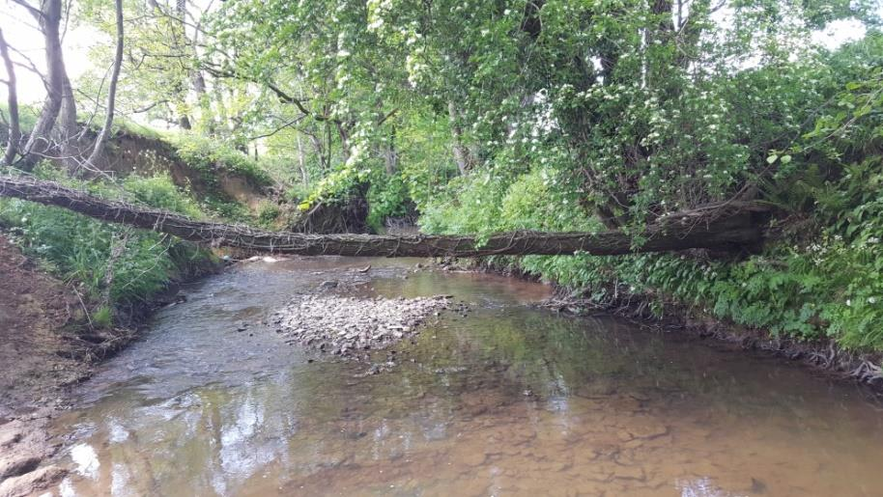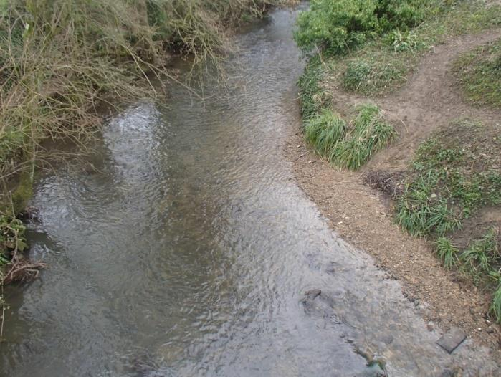

6

15 March 2020

**4.**

**Measurement sites**

**4.1.**

**Cook’s Farm**

**4.3.**

**Church Bridge**

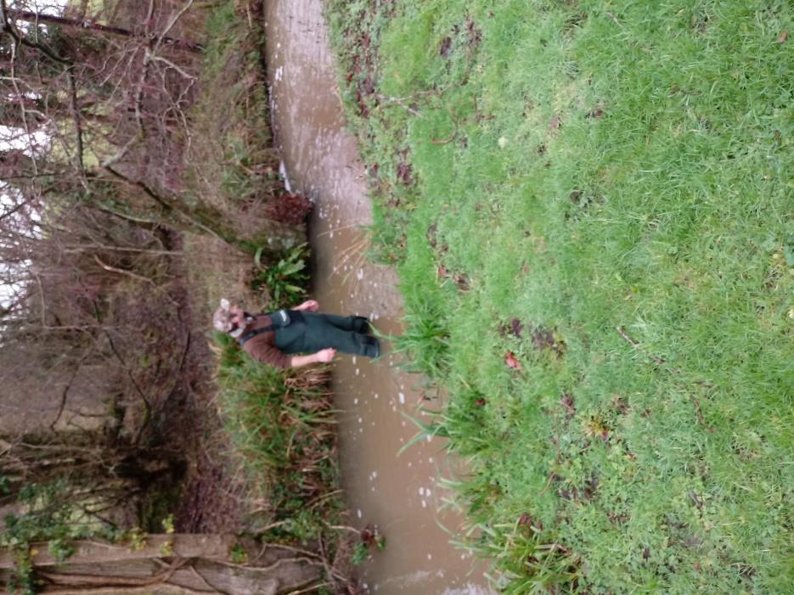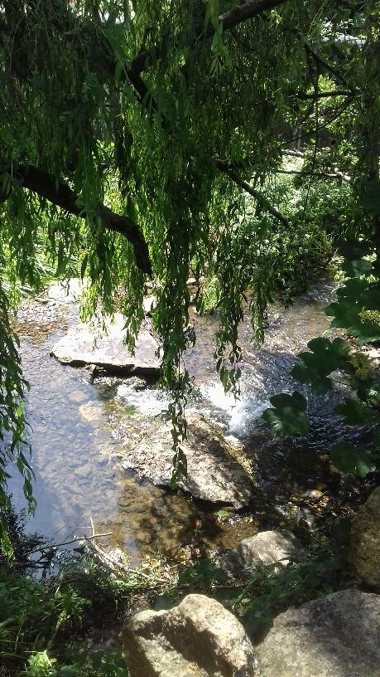

**4.4.**

**Cole Manor**

**4.2.**

**Three Ton Bridge**

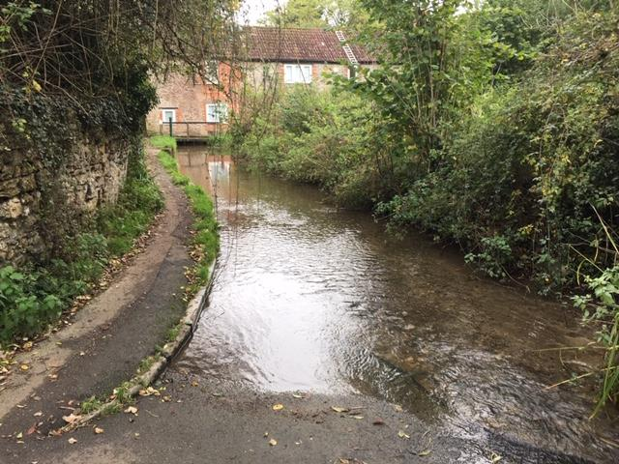

7

15 March 2020

**4.5.**

**Pitcombe**

**4.6.**

**On the Brook**

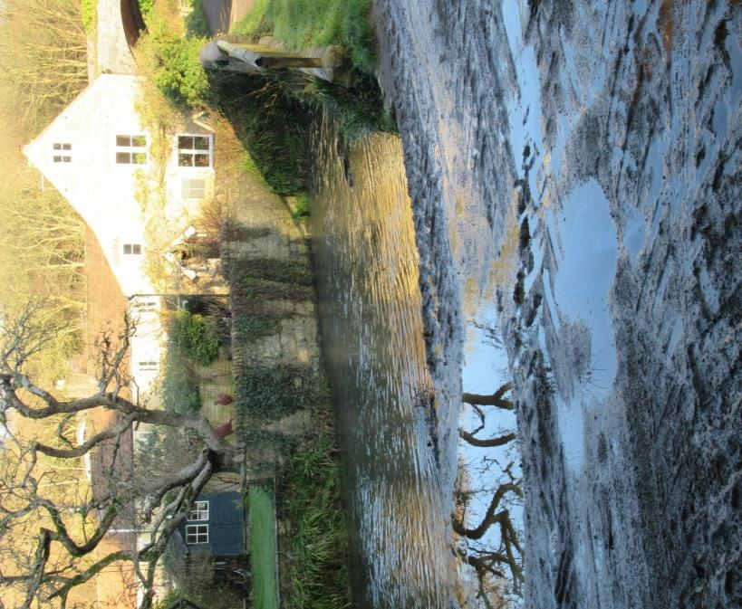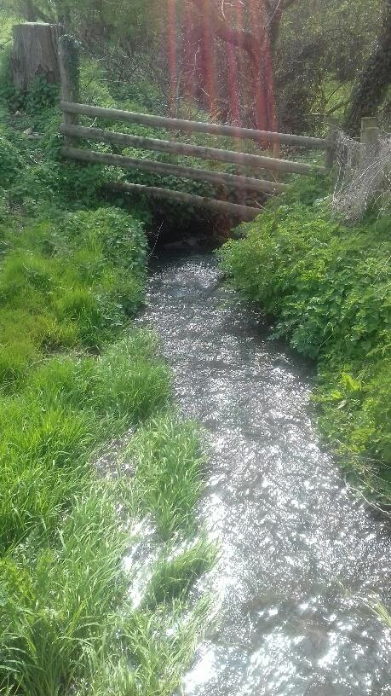

**4.7.**

**Combe Brook Mill Dam**

**1**

**Caseless caddisfly**

**2**

**1**

**0**

**0**

**0**

**0**

**4**

**0**

**0**

**3**

**1**

**10**

**2**

**2**

**1**

**4**

**1**

**1**

**2**

**1**

**0**

**0**

**0**

**0**

**1**

**0**

**0**

**4**

**1**

**0**

**0**

**0**

**20**

**1**

**2**

**1**

**2**

**1**

**0**

**0**

**0**

**0**

**2**

**15**

**2**

**2**

**1**

**1**

**1**

**0**

**Blue-winged olive**

**(Ephemerellidae)**

**0**

**0**

**2**

**1**

**0**

**1**

**1 20+**

**2**

**10**

**2**

**40**

**2**

**1**

**0**

**2**

**1**

**5**

**1 20+**

**2 30+**

**2**

**Mayfly (Ephemeridae)**

**5**

**1**

**1**

**0**

**0**

**2**

**1**

**3**

**1**

**Three Ton Bridge**

**Jan**

**Month**

**July**

**Aug**

**Sept**

**Oct**

**Nov**

**Feb**

**March**

**April**

**May**

**June**

**July**

**Aug**

**Sept**

**Trigger level 10**

The trigger level set by The Environment Agency for Cook’s farm has been set at 10 for the whole of this period

and has not been breached.

**5.1.2.**

**Three Ton Bridge**

**Oct**

**Score**

**Species**

**Est No.**

**Score**

**Est No.**

**Score**

**2019**

**2019**

**2019**

**2019**

**2019**

**2019**

**2019**

**2019**

**2019**

**2019**

**Est No.**

**Est No.**

**Score**

**Est No.**

**Score**

**Est No.**

**Score**

**Est No.**

**Score**

**Est No.**

**Score**

**Est No.**

**Cased caddisfly**

**2**

**1**

**10**

**2**

**Score**

**Score**

**Est No.**

**Score**

**Est No.**

**Score**

**Est No.**

**Score**

**Est No.**

**2019**

**Est No.**

**Score**

**Est No.**

**Score**

**Est No.**

**Score**

**Est No.**

**Score**

**Nov**

**Dec**

**2018**

**2018**

**2018**

**2018**

**2018**

**2019**

**1 20+**

**1**

**3**

**1**

**0**

**0**

**4**

**1**

**10**

**2**

**8**

**1**

**2**

**1**

**50**

**2**

**60**

**2**

**70**

**2 40+**

**2 40+**

**Freshwater shrimp**

**(Gammaridae)**

**1**

**1 20+**

**2**

**2**

**2**

**10**

**1**

**40**

**2**

**20**

**2**

**0**

**0**

**1**

**1**

**2**

**3**

**1**

**20**

**2**

The trigger level for Three Ton Bridge set by The Environment Agency was adjusted down from 12 to 7 on 28th May 2019

and has not been breached.

**Trigger level 7**

8

15 March 2020

**13**

**12**

**8**

**10**

**0**

**0**

**ARMI score**

**6**

**7**

**8**

**5**

**9**

**9**

**14**

**15**

**0**

**15**

**9**

**11**

**22**

**1**

**3**

**1**

**2**

**1**

**30**

**2**

**12**

**2**

**6**

**2 30+**

**2 40+**

**2**

**30**

**2**

**40**

**2**

**10**

**2**

**Flat bodied stone**

**clinger (Heptageniidae)**

**6**

**1 30+**

**2 30+**

**2**

**2**

**50**

**2**

**15**

**2**

**10**

**2**

**0**

**0 10+**

**2 30+**

**2**

**2**

**10**

**2**

**30**

**2**

**0**

**0 10+**

**2 20+**

**1**

**Stoneflies (Plecoptera)**

**0**

**0**

**1**

**0**

**0**

**0**

**0**

**20**

**2**

**15**

**2**

**0**

**0**

**30**

**2**

**30**

**2 20+**

**2 20+**

**2**

**3**

**20**

**Olives (Baetidae)**

**8**

**1**

**0**

**0 50+**

**2**

**2**

**12**

**2**

**24**

**2 100+**

**3 200+**

**3**

**200**

**3**

**4**

**1**

**7**

**1**

**6**

**1**

**1**

**5**

**1**

**1**

**1**

**0**

**0**

**2**

**1**

**0**

**0**

**3**

**1**

**1**

**1**

**1**

**Caseless caddisfly**

**1**

**2**

**5**

**1**

**1**

**0**

**0**

**5**

**1**

**6**

**10**

**2**

**25**

**2**

**68**

**2**

**22**

**2**

**37**

**2**

**86**

**55**

**2**

**2**

**Blue-winged olive**

**18**

**1**

**60**

**2**

**22**

**2**

**8**

**1**

**16**

**2**

**5**

**2**

**6**

**1**

**0**

**0**

**12**

**2**

**13**

**2**

**1**

**Mayfly (Ephemeridae)**

**6**

**1**

**2**

**2**

**0**

**0 10+**

**2**

**42**

**2**

**96**

**2**

**26**

**Cook's Farm**

**Dec**

**Nov**

**Feb**

**Month**

**July**

**Aug**

**Sept**

**Oct**

**Nov**

**Jan**

**March**

**April**

**May**

**June**

**July**

**Aug**

**Sept**

**Oct**

with the Environmental Agency set trigger level for the site.

**5.**

**Review of measurements**

**5.1.**

**Species Abundance month by month**

The estimated number of each species in a sample is recorded and gives a numerical score using a standardised

logarithmic method. One to 10 is given a score of one, 11 to 100 scores 2, over 100 but less than 1000 scores 3

and over 1000 scores 4. The individual species’ scores are then added to give the ARMI score which is compared

Blank squares in the data tables indicate that no data was collected for that particular month, if a species was

not present in the sample this is indicated by a zero

**5.1.1.**

**Cook’s Farm**

**Est No.**

**Score**

**Est No.**

**Score**

**Est No.**

**Score**

**Est No.**

**Score**

**Est No.**

**Score**

**Est No.**

**Score**

**Est No.**

**Score**

**Est No.**

**Score**

**Est No.**

**Score**

**Est No.**

**Score**

**Species**

**Est No.**

**Score**

**Est No.**

**Score**

**2**

**2**

**32**

**2**

**6**

**1**

**5**

**1**

**130**

**3**

**26**

**1**

**120**

**3**

**2**

**1**

**1**

**1**

**20**

**Est No.**

**Est No.**

**Score**

**Est No.**

**Score**

**Est No.**

**Score**

**Est No.**

**Score**

**Score**

**Cased caddisfly**

**90**

**2**

**2019**

**2019**

**2019**

**2019**

**2019**

**2019**

**2019**

**2019**

**2019**

**2019**

**(Ephemerellidae)**

**2018**

**2018**

**2018**

**2018**

**2018**

**2019**

**2019**

**66**

**73**

**2 10+**

**2**

**180**

**3**

**100**

**3**

**220**

**3**

**2**

**2**

**70**

**2**

**120**

**3**

**220**

**3**

**350**

**Freshwater shrimp**

**(Gammaridae)**

**30**

**2**

**4**

**1**

**20**

**3**

**50**

**2 20+**

**2 20+**

**2**

**132**

**3**

**57**

**2**

**120**

**Stoneflies (Plecoptera)**

**117**

**3**

**50**

**2**

**34**

**2**

**20**

**2**

**1**

**2**

**1**

**20**

**2**

**54**

**2**

**36**

**2**

**20**

**3**

**30**

**1**

**30**

**2**

**16**

**12**

**12**

**17**

**16**

**17**

**13**

**16**

**15**

**15**

**16**

**ARMI score**

**13**

**11**

**11**

**13**

**13**

**17**

**127**

**3**

**236**

**3**

**250**

**3**

**120**

**3**

**Flat bodied stone**

**clinger (Heptageniidae)**

**2**

**1**

**5**

**1 10+**

**2**

**2**

**120**

**3**

**170**

**3**

**164**

**3**

**130**

**3**

**19**

**3**

**76**

**2**

**112**

**3 300+**

**3**

**120**

**3**

**152**

**96**

**2**

**52**

**2**

**60**

**2**

**33**

**2**

**0**

**2**

**200**

**3**

**130**

**3**

**120**

**3**

**4**

**1**

**30**

**0**

**0**

**0**

**0**

**0**

**0**

**50**

**2**

**4**

**1**

**0**

**0**

**0**

**0**

**0**

**0**

**0**

**0**

**0**

**0**

**0**

**0**

**0**

**40**

**2**

**3**

**115**

**2**

**93**

**2**

**72**

**2**

**50**

**2**

**100**

**3**

**3**

**140**

**3**

**62**

**2**

**120**

**3**

**105**

**30**

**2 10+**

**Olives (Baetidae)**

**95**

**2 10+**

**2**

**42**

**2**

**16**

**2**

**66**

**2**

**1**

**2**

**1**

**2**

**1**

**2**

**1**

**Caseless caddisfly**

**2**

**1**

**6**

**1**

**8**

**5**

**1**

**20**

**2**

**6**

**1**

**5**

**1**

**2**

**2**

**2**

**30**

**2**

**70**

**2**

**120**

**3**

**70**

**10**

**15**

**2**

**0**

**0**

**2**

**1**

**0**

**0**

**Blue-winged**

**olive**

**(Ephemerellidae)**

**10**

**2**

**1**

**Mayfly**

**(Ephemeridae)**

**1**

**1**

**1**

**4**

**1**

**4**

**1**

**2**

**1**

**7**

**1**

**1**

**0**

**0**

**0**

**0**

**1**

**1**

**10**

**1**

**Month**

**July**

**Aug**

**Sept**

**Oct**

**Nov**

**Jan**

**Feb**

**March**

**Cole Manor**

The trigger level for Church Bridge set by The Environment Agency was adjusted down from 10 to 4 on 24th May 2019 and

was breached in Nov 2018 but was judged to indicate a natural variation in the invertebrate population.

**5.1.4**

**Cole Manor**

**April**

**2019**

**2019**

**2019**

**2018**

**2018**

**2018**

**2018**

**2018**

**2019**

**2019**

**2019**

**2019**

**2019**

**2019**

**2019**

**2019**

**2019**

**2**

**1**

**8**

**1**

**2**

**1**

**10**

**2**

**20**

**6**

**15**

**2**

**15**

**2**

**3**

**1**

**5**

**1**

**Est No. Score Est No. Score Est No. Score Est No. Score Est No.**

**Species**

**Est No.**

**Score**

**Est No. Score Est No. Score**

**Score Est No. Score Est No. Score Est No.**

**Score Est No. Score Est No. Score Est No. Score Est No.**

**Score Est No. Score Est No. Score**

**Cased caddisfly**

**May**

**June**

**July**

**Aug**

**Sept**

**Oct**

**Nov**

**Dec**

**2**

**70**

**2**

**15**

**1**

**(Gammaridae)**

**4**

**1**

**2**

**1**

**3**

**1**

**2**

**0**

**0**

**1**

**1**

**0**

**0**

**0**

**0**

**shrimp**

**Freshwater**

9

15 March 2020

**Trigger level 7**

The Environment Agency set the trigger level for Cole Manor at 7. This was breached in Aug 2019.

**0**

**0**

**ARMI score**

**0**

**0**

**0**

**0**

**8**

**0**

**9**

**10**

**12**

**12**

**11**

**10**

**6**

**8**

**10**

**1**

**0**

**0**

**1**

**1**

**1**

**0**

**Flat bodied stone**

**clinger**

**(Heptageniidae)**

**0**

**0**

**0**

**0**

**0**

**3**

**1**

**5**

**1**

**4**

**1**

**0**

**0**

**2**

**1**

**2**

**1**

**0**

**0**

**5**

**1**

**15**

**8**

**1**

**1**

**0**

**0**

**2**

**1**

**Stoneflies**

**(Plecoptera)**

**0**

**0**

**3**

**1**

**2**

**Olives (Baetidae)**

**12**

**15**

**2**

**100**

**3**

**200**

**3**

**120**

**3**

**70**

**2**

**2**

**120**

**3**

**15**

**2**

**30**

**2**

**70**

**7**

**1**

**6**

**3**

**1**

**6**

**1**

**3**

**1**

**4**

**1**

**1**

**10**

**2**

**10**

**2**

**6**

**1**

**2**

**0**

**1**

**Caseless caddisfly**

**0**

**2**

**1**

**2**

**1**

**0**

**0**

**2**

**1**

**0**

**Blue-winged olive**

**(Ephemerellidae)**

**162**

**3**

**8**

**1**

**4**

**1**

**0**

**0**

**0**

**5**

**1**

**0**

**0**

**2**

**0**

**Mayfly**

**(Ephemeridae)**

**0**

**0**

**0**

**0**

**0**

**1**

**1**

**0**

**0**

**0**

**0**

**2**

**1**

**1**

**0**

**0**

**3**

**1**

**3**

**1**

**0**

**0**

**1**

**1**

**1**

**3**

**1**

**1**

**1**

**Month**

**July**

**Aug**

**Church Bridge**

**June**

**Sept**

**Oct**

**Nov**

**Jan**

**Feb**

**March**

**April**

**May**

**July**

**Aug**

**Sept**

**Oct**

**Nov**

**Dec**

**5.1.3**

**Church Bridge**

**Est No. Score Est No. Score**

**Est No. Score Est No. Score Est No. Score Est No. Score Est No.**

**Score Est No. Score Est No. Score Est No.**

**Score Est No. Score Est No. Score Est No. Score Est No.**

**Score Est No. Score Est No.**

**Score**

**Cased caddisfly**

**1**

**1**

**2**

**1**

**2**

**1**

**1**

**1**

**Score**

**Species**

**Est No.**

**1**

**4**

**1**

**2**

**1**

**1**

**15**

**0**

**0**

**17**

**2**

**20**

**2**

**8**

**1**

**2**

**15**

**2**

**0**

**0**

**8**

**1**

**2019**

**2019**

**2019**

**2019**

**2019**

**2019**

**2019**

**2019**

**2019**

**2019**

**1**

**2018**

**2018**

**2018**

**2018**

**2018**

**2019**

**2019**

**1**

**1**

**4**

**1**

**6**

**1**

**7**

**1**

**1**

**1**

**0**

**0**

**4**

**1**

**2**

**1**

**20**

**2**

**Freshwater shrimp**

**(Gammaridae)**

**4**

**1**

**1**

**1**

**3**

**1**

**1**

**0**

**0**

**0**

**0**

**0**

**4**

**1**

**2**

**0**

**0**

**0**

**1**

**1**

**0**

**0**

**1**

**1**

**1**

**Stoneflies**

**(Plecoptera)**

**0**

**0**

**0**

**0**

**1**

**6**

**1**

**5**

**1**

**2**

**1**

**25**

**7**

**7**

**8**

**6**

**10**

**11**

**8**

**11**

**10**

**0**

**6**

**0**

**ARMI score**

**11**

**7**

**4**

**5**

**3**

**Trigger level 4**

**2**

**50**

**2**

**5**

**1**

**0**

**12**

**2**

**6**

**1**

**0**

**0**

**0**

**0**

**(Heptageniidae)**

**0**

**0**

**0**

**0**

**0**

**0**

**0**

**3**

**1**

**Flat bodied stone**

**clinger**

**0**

**4**

**1**

**0**

**0**

**3**

**1**

**1**

**1**

**0**

**0**

**0**

**3**

**3**

**1**

**50**

**2**

**6**

**1**

**50**

**2**

**1**

**0**

**0**

**0**

**0**

**5**

**500**

**3**

**1**

**1**

**20**

**2**

**8**

**1**

**1**

**3**

**1**

**24**

**2**

**7**

**1**

**4**

**1**

**24**

**2**

**3**

**1**

**50**

**2**

**18**

**2**

**120**

**3**

**150**

**Olives (Baetidae)**

**200**

**0**

**0**

**0**

**0**

**9**

**Caseless caddisfly**

**13**

**2**

**1**

**4**

**1**

**0**

**0**

**4**

**1**

**1**

**1**

**2**

**0**

**0**

**0**

**0**

**1**

**1**

**20**

**2**

**1**

**1**

**2**

**0**

**0**

**(Ephemerellidae)**

**olive**

**Blue-winged**

**(Ephemeridae)**

**Mayfly**

**2**

**1**

**0**

**0**

**0**

**0**

**0**

**0**

**1**

**1**

**1**

**0**

**0**

**0**

**0**

**On the Brook**

**April**

**July**

**Aug**

**Sept**

**Oct**

**Nov**

**Jan**

**Feb**

**March**

**Month**

**May**

**June**

**July**

**Aug**

**Sept**

**Oct**

**Nov**

**On The Brook**

**5.1.6**

of a pollution incident..

breached in August 2019 but a second sample taken a week later was above the trigger level and not indicative

The Environment Agency adjusted the trigger level at Pitcombe down from 10 to 7 in September 2019. This was

**Trigger level 7**

**Dec**

**2019**

**2018**

**2018**

**2018**

**2018**

**2019**

**2019**

**2019**

**2019**

**2019**

**2019**

**2019**

**2019**

**2019**

**2019**

**2019**

**1**

**Cased caddisfly**

**11**

**2**

**7**

**1**

**1**

**1**

**1**

**2**

**1**

**2**

**2018**

**Score Est No. Score Est No.**

**Score Est No. Score Est No. Score Est No. Score Est No.**

**Score Est No. Score Est No. Score Est No.**

**Est No. Score Est No. Score Est No. Score Est No. Score Est No.**

**Est No. Score Est No. Score**

**Score**

**Est No.**

**Species**

**Score**

**3**

**150**

**3**

**300**

**3**

**150**

**150**

**Freshwater**

**shrimp**

**(Gammaridae)**

**3**

**40**

**2**

**70**

**2**

**120**

**3**

**Trigger level 10**

The Environment Agency adjusted the trigger level at On The Brook down from 10 to 4 in September 2019.

10

15 March 2020

**8**

**0**

**0**

**0**

**0**

**0**

**0**

**0**

**11**

**0**

**7**

**4**

**8**

**8**

**0**

**7**

**0**

**ARMI score**

**0**

**0**

**0**

**0**

**0**

**0**

**0**

**0**

**0**

**0**

**0**

**0**

**0**

**0**

**(Heptageniidae)**

**Flat bodied stone**

**clinger**

**0**

**0**

**0**

**0**

**0**

**0**

**0**

**0**

**0**

**0**

**0**

**0**

**0**

**(Plecoptera)**

**Stoneflies**

**0**

**Olives (Baetidae)**

**250**

**3**

**120**

**3**

**112**

**3**

**0**

**10**

**2**

**80**

**2**

**6**

**1**

**1**

**0**

**1**

**1**

**1**

**4**

**1**

**5**

**1**

**0**

**2**

**1**

**0**

**0**

**0**

**0**

**1**

**2**

**Caseless caddisfly**

**1**

**30**

**20**

**2**

**10+**

**2**

**4**

**1**

**3**

**(Ephemerellidae)**

**0**

**0**

**0**

**0**

**12**

**2**

**2**

**Blue-winged olive**

**5**

**Mayfly**

**(Ephemeridae)**

**10**

**2**

**5**

**1**

**0**

**0**

**0**

**0**

**1**

**4**

**1**

**1**

**8**

**1**

**1**

**1**

**1**

**Pitcombe**

**Aug**

**Sept**

**Oct**

**Nov**

**Dec**

**July**

**June**

**May**

**April**

**March**

**Feb**

**Jan**

**Nov**

**Oct**

**Sept**

**Aug**

**July**

**Month**

**Pitcombe Bridge**

**5.1.5**

**Score**

**Species**

**Est No.**

**Score**

**Est No. Score Est No. Score**

**Est No. Score Est No. Score Est No. Score Est No. Score Est No.**

**2019**

**2019**

**2019**

**2019**

**Score Est No. Score Est No. Score Est No.**

**2**

**0**

**0**

**14**

**2**

**16**

**2**

**2**

**16**

**1**

**2019**

**1**

**1**

**3**

**1**

**7**

**2**

**15**

**14**

**Cased caddisfly**

**Score Est No. Score Est No.**

**Score Est No. Score Est No. Score Est No. Score Est No.**

**2018**

**2018**

**2018**

**2018**

**2018**

**2019**

**2019**

**2019**

**2019**

**2019**

**2019**

**2019**

**15**

**2**

**Freshwater shrimp**

**(Gammaridae)**

**150**

**150**

**3**

**100+**

**3**

**80**

**200**

**3**

**150**

**3**

**150**

**3**

**200**

**3**

**3**

**120**

**3**

**2**

**15**

**0**

**1**

**2**

**1**

**4**

**1**

**3**

**0**

**0**

**8**

**0**

**0**

**0**

**0**

**0**

**15**

**13**

**9**

**0**

**6**

**9**

**12**

**12**

**13**

**1**

**0**

**0**

**ARMI score**

**0**

**0**

**0**

**0**

**0**

**0**

**0**

**0**

**0**

**1**

**0**

**0**

**clinger**

**Flat bodied stone**

**(Heptageniidae)**

**0**

**0**

**0**

**0**

**0**

**4**

**2**

**Stoneflies**

**(Plecoptera)**

**0**

**20**

**2**

**10+**

**2**

**2**

**3**

**70**

**2**

**2**

**80**

**2**

**15**

**1**

**1**

**2**

**15**

**3**

**150**

**3**

**300+**

**3**

**100**

**140**

**Olives (Baetidae)**

**30**

**2**

**2**

**37**

**1**

**3**

**1**

**1**

**2**

**12**

**3**

**2**

**135**

**3**

**130**

**3**

**125**

**1**

**3**

**1**

**0**

**0**

**Olives (Baetidae)**

**Stoneflies (Plecoptera)**

**0**

**0**

**1**

**6**

**1**

**2**

**0**

**0**

**0**

**1**

**0**

**2**

**10**

**1**

**0**

**0**

**0**

**0**

**0**

**0**

**0**

**1**

**3**

**1**

**0**

**0**

**0**

**1**

**1**

**1**

**1**

**1**

**1**

**0**

**0**

**0**

**0**

**0**

**0**

**clinger (Heptageniidae)**

**Flat bodied stone**

**0**

**0**

**0**

**0**

**0**

**0**

**7**

**0**

**4**

**4**

**4**

**6**

**8**

**8**

**9**

**0**

**0**

**5**

**6**

**0**

**0**

**ARMI score**

**0**

**3**

15 March 2020

11

vehicles.

site is a ford and as such appears to have a large variation in species numbers possibly due to disturbance by passing motor

The Environment Agency adjusted the trigger level for Combe Brook Mill Dam down from 10 to 5 on 28th May 2019. This

**Trigger level 5**

**2**

**40**

**2**

**41**

**(Gammaridae)**

**Freshwater shrimp**

**31**

**20**

**9**

**2**

**94**

**2**

**32**

**2**

**23**

**2**

**1**

**5**

**1**

**1**

**2**

**12**

**2**

**7**

**2019**

**2019**

**2018**

**2018**

**2018**

**2018**

**2018**

**2019**

**2019**

**2019**

**2019**

**2019**

**2019**

**2019**

**2019**

**2019**

**2019**

**Est No.**

**Est No.**

**Score**

**Est No.**

**Score**

**Est No.**

**Score**

**Score**

**Est No.**

**Score**

**Est No.**

**Score**

**Est No.**

**Score**

**Est No.**

**1**

**1**

**4**

**1**

**7**

**0**

**0**

**0**

**0**

**Score**

**1**

**Cased caddisfly**

**Species**

**Score**

**Est No.**

**Est No.**

**Est No.**

**Score**

**Est No.**

**Score**

**Est No.**

**Score**

**Est No.**

**Score**

**Score**

**Est No.**

**Score**

**Est No.**

**Score**

**Est No.**

**Score**

**Combe Brook Mill Dam**

**5.1.7**

**June**

**Dec**

**Nov**

**Oct**

**Sept**

**Aug**

**July**

**May**

**April**

**March**

**Feb**

**Jan**

**Nov**

**Oct**

**Sept**

**Aug**

**Combe Brook**

**July**

**Month**

**3**

**0**

**0**

**0**

**0**

**0**

**0**

**0**

**0**

**0**

**0**

**0**

**0**

**0**

**0**

**0**

**1**

**3**

**1**

**6**

**1**

**3**

**Mayfly (Ephemeridae)**

**0**

**(Ephemerellidae)**

**Blue-winged olive**

**0**

**2**

**0**

**0**

**0**

**0**

**1**

**7**

**2**

**31**

**40**

**2**

**25**

**0**

**0**

**1**

**1**

**0**

**0**

**0**

**0**

**0**

**0**

**0**

**1**

**1**

**1**

**0**

**0**

**0**

**0**

**0**

**0**

**Caseless caddisfly**

**0**

**0**

**1**

**0**

**0**

**0**

**0**

**0**

**1**

**0**

**0**

**0**

**0**

**0**

**0**

15

0

Church Bridge

1

2

2

1

0

17

20

8

15

4

0

8

1

4

2

Cole Manor

6

8

2

10

20

130

2

120

2

1

20

25

68

22

37

86

55

15

Three Ton Bridge

2

10

5

2

2

0

0

20

15

2

1

0

0

0

0

On the Brook

11

7

1

1

2

2

1

0

12

15 March 2020

16

15

3

5

10

Pitcombe

15

7

3

1

0

14

5

14

16

Combe Brook

1

0

0

7

4

3

1

120

100

80

**Estimated number**

60

40

20

0

140

Est No.

Est No.

Est No.

Est No.

**6**

**Species variation from site to site**

Graphs showing abundance against site and month for each species are described in this section of the report.

When we commenced this activity we had no previous data or insight into what, if any, was the seasonal

variation in invertebrate numbers or indeed if there was any correlation in numbers between sites. The results

do suggest that there is some seasonal variation with different species peaking at different times of the year but

the size of the population of the sampled invertebrate species is specific to the river environmental conditions at

each individual site. Low water levels combined with higher temperatures in the summer months can result in

depletion of oxygen levels with consequent reduction in numbers of invertebrates. It is important to understand

if breaches of trigger levels are a consequence of weather and other environmental effects rather than pollution,

to avoid raising false alarms. It is therefore likely that we will need to acquire several years of data before we can

be confident that a breach of the trigger level at a given site is due to a pollution event.

Est No.

**6.1**

**Cased Caddis**

The number of cased caddis seen at Cook’s farm greatly exceeds that seen at any other sampling location on the

upper Brue and its tributaries. The reason for this remains a mystery. Further downstream and at Pitcombe the

abundance of cased caddis is similar at each sampling site but is 20 or less. However with the exception of one

sample in April 2019 the numbers in Combe Brook are lower than in the Brue. One observation is that well

developed cased caddis are large and easy to identify but they start off very small 2-3mm and can be easily

missed.

**Cased Caddis**

May

2019

2019

2019

July

Aug

Sept

Oct

Nov

Jan

Feb

Mar

April

2019

June

July

Aug

Sept

Oct

Nov

Dec

Cook's Farm

90

26

32

6

2018

Est No.

Est No.

Est No.

Est No.

Est No.

Est No.

Est No.

Est No.

Est No.

Est No.

Est No.

Est No.

2018

2018

2018

2018

2018

2019

2019

2019

2019

2019

2019

2019

2

0

2

0

3

6

3

4

6

10

10

6

2

7

2

Cole Manor

2

6

8

5

20

6

5

2

2

2

4

0

2

0

3

0

5

6

10

Three Ton Bridge

2

0

0

Pitcombe

0

3

10

2

4

2

0

0

1

0

Church Bridge

0

4

0

0

4

13

15 March 2020

0

4

5

0

2

0

0

1

2

1

Combe Brook

0

0

3

0

0

0

0

1

0

0

0

On the Brook

13

9

Est

Est

Est

Est

Est

Est

Est

Est

Est

Est

Est

Est

Est

Est

Est

Est

Est

No.

No.

No.

No.

**Caseless Caddis**

**6.2**

**Caseless Caddis**

Small numbers of caseless caddis are generally recorded at most sites. Only Cole Manor recorded more than twenty

and that was only in May 2019. This species is more frequent between February and August.

No.

25

20

15

**Estimated number**

10

5

0

Aug

2019

July

Aug

Sept

Oct

Nov

Jan

Feb

Mar

April

May

June

July

2019

Sept

Oct

Nov

Dec

Cook's Farm

5

1

4

7

6

1

1

5

2018

No.

No.

No.

No.

No.

No.

No.

No.

No.

No.

No.

No.

2018

2018

2018

2018

2018

2019

2019

2019

2019

2019

2019

2019

2019

2019

Cole Manor

0

0

5

0

2

3

50

6

50

3

0

0

4

10

10

30

70

120

70

15

0

2

0

Pitcombe

20

10

200

130

120

4

0

0

0

Three Ton Bridge

0

2

30

15

15

0

15

40

50

10

30

0

15

30

Church Bridge

162

8

2

Series8

0

20

14

15 March 2020

40

4

3

0

0

12

30

15

Combe Brook

0

1

0

25

30

31

7

0

0

7

3

On the Brook

0

2

0

0

1

Est

Est

Est

Est

Est

Est

Est

Est

Est

Est

Est

Est

Est

Est

Est

Est

Est

No.

No.

No.

No.

**6.3**

**Blue Winged Olive**

Most sites see a maximum in the Blue Winged Olive population during spring and summer, though for some reason

there is a second flush in the late autumn at Pitcombe and Three Ton Bridge. Again Cook’s farm is showing the

highest numbers.

No.

**Blue-winged olive (Ephemerellidae)**

250

200

150

**Estimated number**

100

50

0

Sept

July

Aug

Sept

Oct

Nov

Jan

Feb

Mar

April

May

June

July

Aug

2019

Oct

Nov

Dec

Cook's Farm

50

4

0

0

0

0

0

0

0

2018

No.

No.

No.

No.

No.

No.

No.

No.

No.

No.

No.

No.

2018

2018

2018

2018

2018

2019

2019

2019

2019

2019

2019

2019

2019

2019

2019

1

0

0

2

0

3

3

0

1

1

3

1

Cole Manor

1

1

4

4

2

1

0

0

1

7

Pitcombe

10

5

25

6

0

12

13

18

Three Ton Bridge

1

0

2

3

0

1

0

10

40

1

2

5

25

35

Church Bridge

0

0

0

1

0

15

15 March 2020

0

0

1

1

8

5

4

Combe Brook

3

6

3

0

0

5

0

0

0

0

0

On the Brook

2

0

0

0

0

Est

Est

Est

Est

Est

Est

Est

Est

Est

Est

Est

Est

Est

Est

Est

Est

Est

No.

No.

No.

No.

No.

No.

No.

**Estimated number**

**6.4**

**Mayfly**

Far more Mayfly larva are recorded at Cook’s farm than at any other site. The reason for this is unknown. The

population peaks in the winter months at Cook’s farm, in spring at Three Ton Bridge and in April at Pitcombe.

Elsewhere only small numbers are recorded.

**Mayfly (Ephemeridae)**

120

100

80

No.

60

40

20

0

Nov

Aug

Sept

Oct

Nov

Jan

Feb

Mar

April

May

June

July

Aug

Sept

Oct

July

Dec

Cook's Farm

6

2

0

15

42

96

26

60

22

8

16

2018

No.

No.

No.

No.

No.

No.

No.

No.

No.

2018

2018

2018

2018

2018

2019

2019

2019

2019

2019

2019

2019

2019

2019

2019

2019

0

0

0

0

0

3

4

0

3

1

0

0

Cole Manor

0

0

0

3

5

4

0

1

0

1

Pitcombe

0

0

22

33

19

120

170

164

130

Three Ton Bridge

6

3

2

30

12

4

35

45

30

40

10

6

35

35

Church Bridge

12

6

0

0

16

15 March 2020

1

0

0

0

0

0

0

Combe Brook

0

0

0

1

1

60

0

0

0

0

0

On the Brook

0

0

0

0

0

0

Est

Est

Est

Est

Est

Est

Est

Est

Est

Est

Est

Est

Est

Est

Est

Est

Est

No.

No.

No.

No.

No.

No.

300

**6.5**

**Flat Bodied Stone Clinger**

Again far more flat bodied stone clingers are recorded at Cook’s farm than elsewhere, though there is a high number

at Three Ton Bridge. Small numbers or none at all are seen at the remaining sites. The mechanism that results in

depletion of stone clingers at sites downstream from Three Ton Bridge is unknown.

**Flat bodied stone clinger (Heptageniidae)**

400

350

No.

250

**Estimated number**

200

150

100

50

0

Oct

July

Aug

Sept

Oct

Nov

Jan

Feb

Mar

April

May

June

July

Aug

Sept

Nov

Dec

Cook's Farm

2

5

20

76

112

350

120

152

96

52

2018

No.

No.

No.

No.

No.

No.

No.

No.

No.

No.

2018

2018

2018

2018

2018

2019

2019

2019

2019

2019

2019

2019

2019

2019

2019

2019

120

500

1

20

8

5

Cole Manor

12

15

100

200

120

70

150

15

30

70

Pitcombe

100

350

150

15

1

15

80

140

30

Three Ton Bridge

8

0

60

20

12

24

150

250

200

0

30

70

25

25

Church Bridge

200

24

7

4

24

1

50

18

120

17

15 March 2020

Combe Brook

0

2

3

125

130

135

12

1

3

37

30

40

On the Brook

250

120

112

0

10

80

6

Est

Est

Est

Est

Est

Est

Est

Est

Est

Est

Est

Est

Est

Est

Est

Est

Est

No.

No.

No.

No.

No.

No.

No.

No.

No.

No.

No.

No.

0

**6.6**

**Olives**

Olive numbers are seen to peak between March and July when high numbers are recorded at all sites.

**Olives (Baetidae)**

600

500

400

**Estimated number**

300

200

100

No.

15

Feb

Mar

April

May

June

July

Aug

Sept

Oct

Nov

Dec

Cook's Farm

95

Jan

15

42

16

66

30

93

72

50

100

115

140

62

120

105

2019

No.

No.

No.

No.

2018

2018

2018

2018

2018

2018

2019

2019

2019

2019

2019

2019

2019

2019

2019

2019

July

Aug

Sept

Oct

Nov

5

0

1

1

6

5

2

Cole Manor

0

3

8

2

0

1

15

1

0

2

Pitcombe

20

15

2

0

3

4

2

1

30

Three Ton Bridge

0

1

0

0

20

15

5

40

20

0

0

10

3

20

Church Bridge

0

0

0

0

0

4

2

0

18

15 March 2020

0

15

Combe Brook

0

2

6

0

0

0

0

0

1

10

30

On the Brook

0

0

0

0

0

0

0

Est

Est

Est

Est

Est

Est

Est

Est

Est

Est

Est

Est

Est

Est

Est

Est

Est

No.

No.

No.

No.

No.

No.

No.

No.

No.

No.

No.

40

**6.7**

**Stoneflies (Plecoptera)**

Once again the largest numbers are recorded at Cook’s farm with 2018 being particularly high. Here the population

peaks in the autumn and winter months whereas at Cole Manor and Pitcombe it peaks in spring and summer.

**Stoneflies (Plecoptera)**

140

120

100

80

**Estimated number**

60

No.

20

0

50

Jan

Feb

Mar

April

May

June

July

Aug

Sept

Oct

Nov

Dec

Cook's Farm

Nov

25

25

132

57

120

117

50

34

20

1

20

54

36

20

2019

No.

No.

No.

No.

No.

2018

2018

2018

2018

2018

2018

2019

2019

2019

2019

2019

2019

2019

2019

2019

2019

July

Aug

Sept

Oct

1

3

1

4

6

7

1

0

4

2

20

25

50

5

4

Cole Manor

4

2

3

2

0

1

0

0

15

70

3

70

120

220

350

127

236

250

120

Three Ton Bridge

1

30

2

0

4

10

8

2

50

60

70

60

60

Church Bridge

**Observations and Conclusions**

40

70

120

150

150

300

**7**

150

This has been a very successful introduction to Riverfly monitoring. Our enthusiastic volunteers are consolidating

their training with each survey. We would like to thank Ben Fitch of The Riverfly Partnership for his excellent

training and continuing support. Thank you also to Richard Bennett of The Environment Agency for all of his

advice.

19

15 March 2020

41

Pitcombe

150

150

80

200

150

150

200

150

120

Combe Brook

66

40

31

12

1

5

20

23

32

94

9

On the Brook

Est

Est

Est

Est

Est

Est

Est

Est

Est

Est

Est

Est

Est

Est

Est

Est

Est

No.

No.

No.

No.

No.

No.

200

**6.8**

**Freshwater Shrimp**

The highest numbers are seen at Cook’s farm where high numbers are seen throughout the year. Similar results are

obtained at both Pitcombe and On the Brook. Lower numbers are observed at Cole Manor and Church Bridge,

peaking in September and October.

**Freshwater shrimp (Gammaridae)**

400

350

300

250

**Estimated number**

No.

150

100

50

0

Sept

July

Aug

Sept

Oct

Nov

Jan

Feb

Mar

April

May

June

July

Aug

2019

Oct

Nov

Dec

Cook's Farm

30

4

20

73

15

180

100

220

2018

No.

No.

No.

No.

No.

No.

No.

No.

No.

No.

2018

2018

2018

2018

2018

2019

2019

2019

2019

2019

2019

2019

2019

2019

2019